**Creation of S3 Bucket**

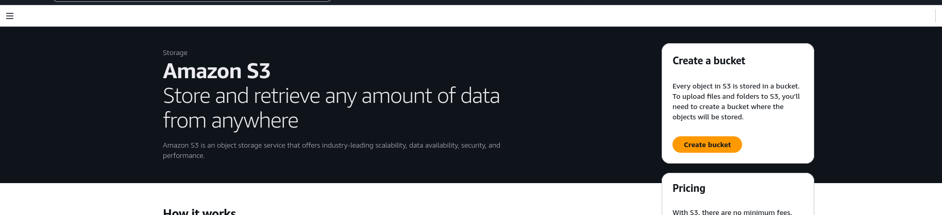

Create the S3 bucket and upload the object into it   
  
i) Change the bucket level permissions   
ii) Change the object level permissions   
iii) Make the bucket publicly accessible   
  
Note:- Upload the document with i) URL of object ii) Screenshots of each and every step

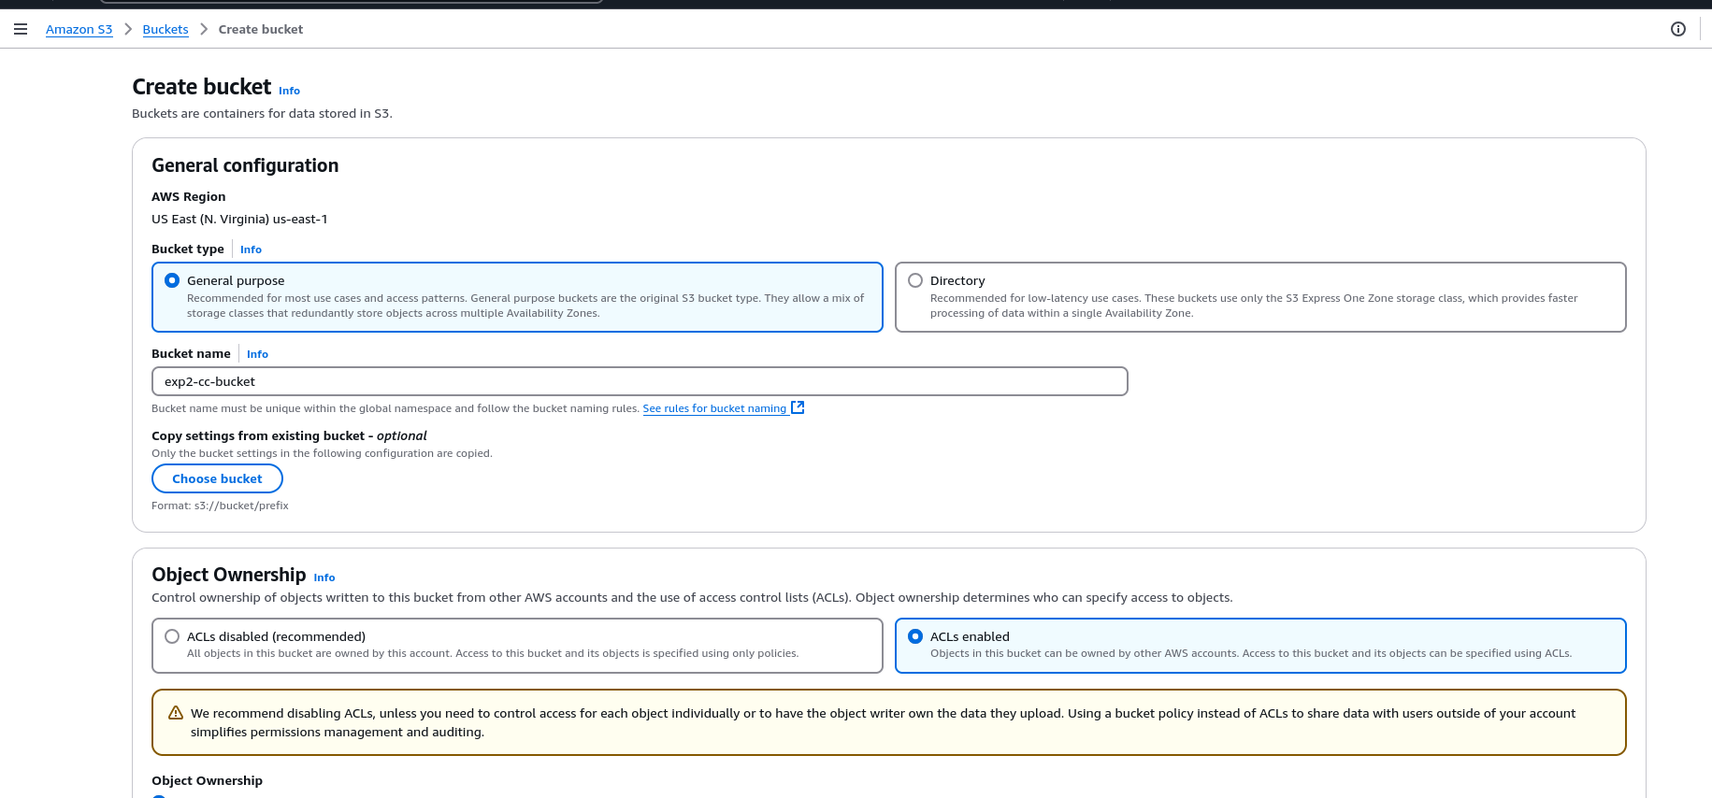

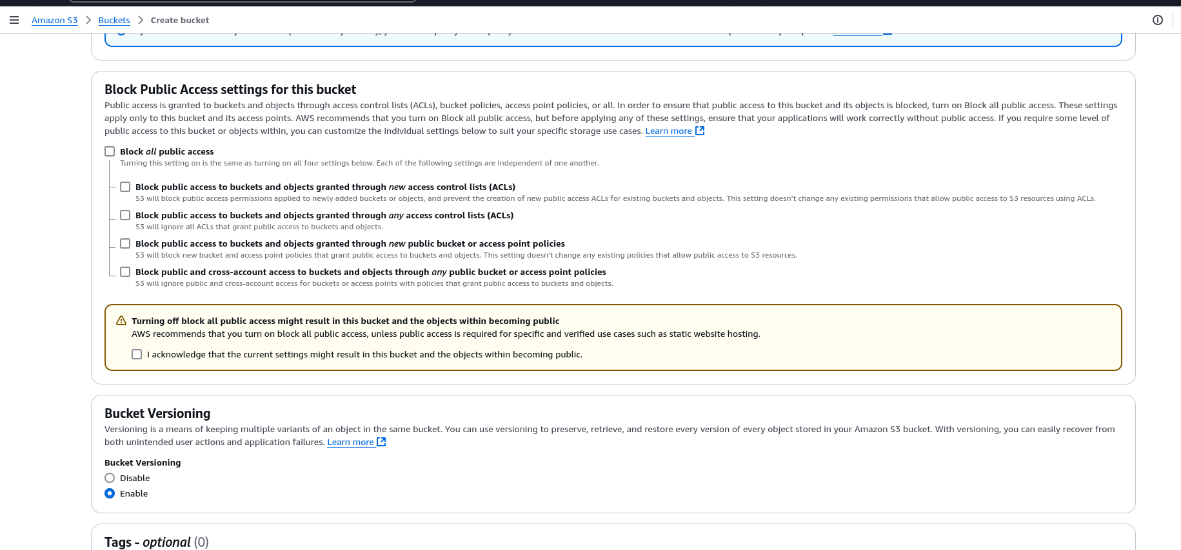

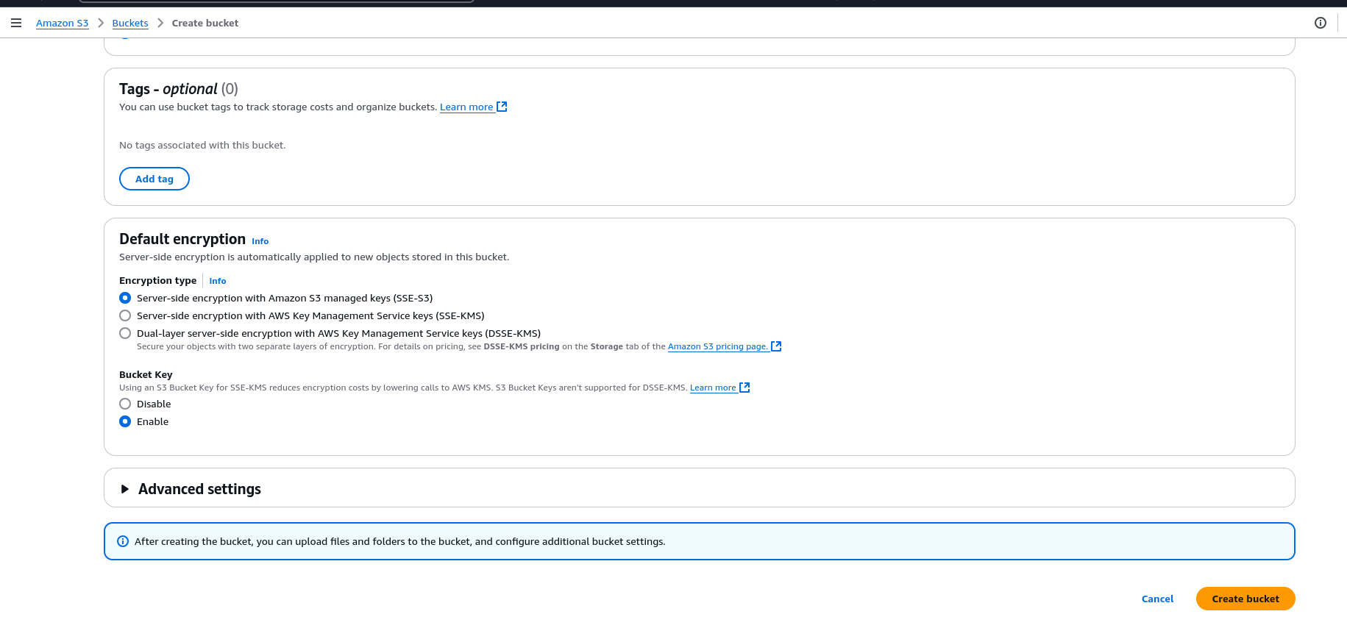

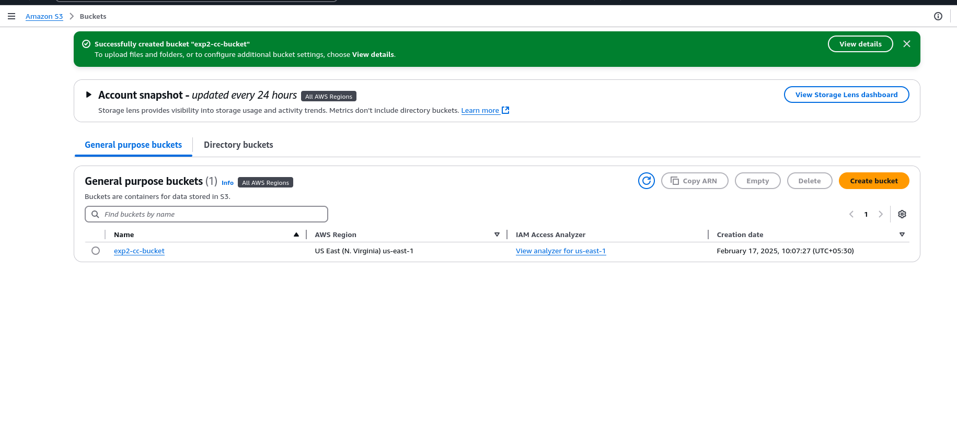

Click on upload

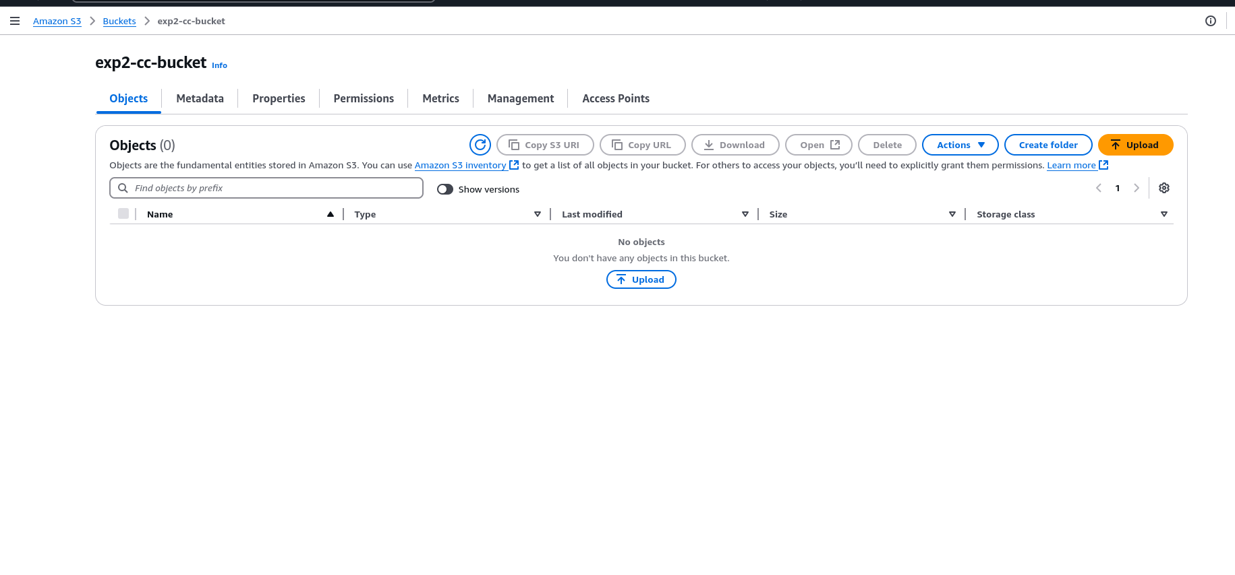

Click on Add files

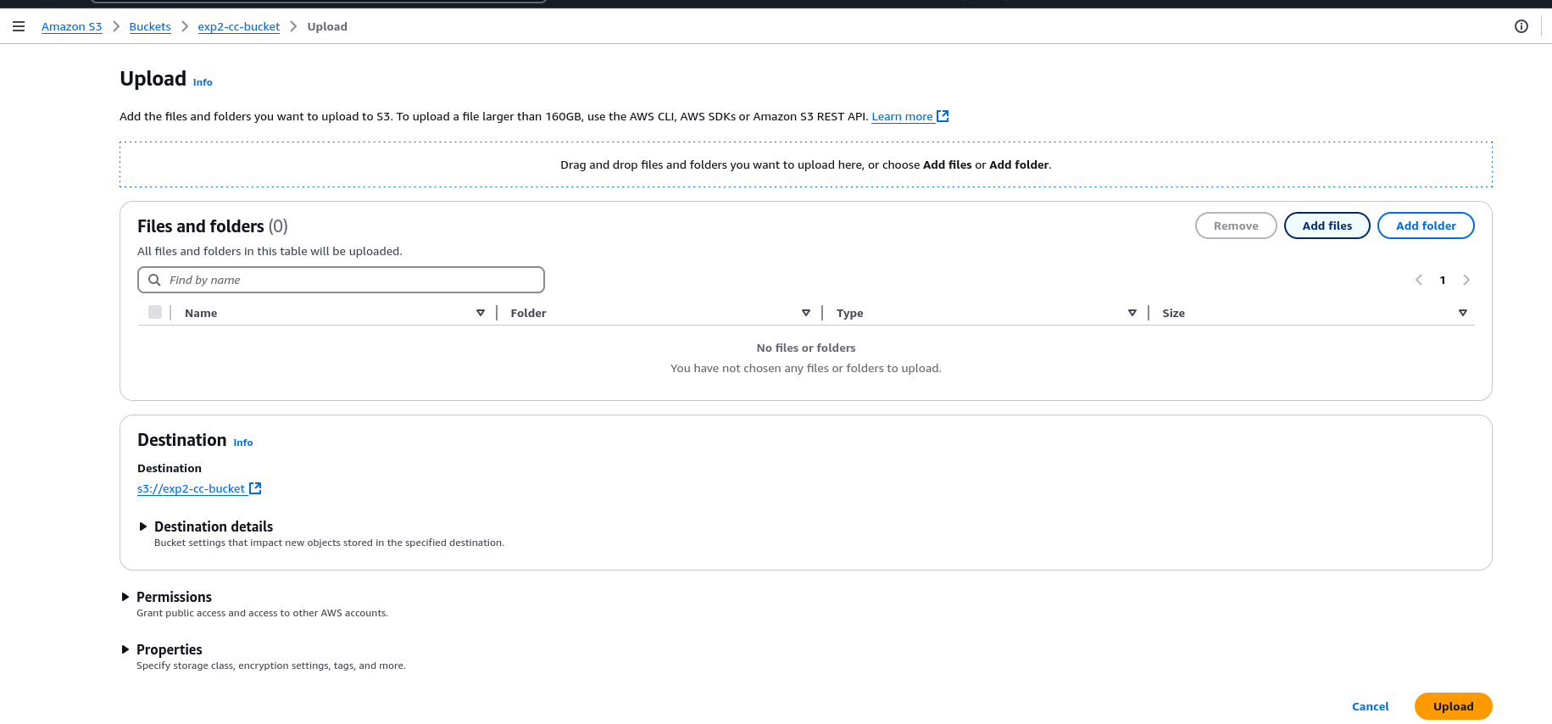

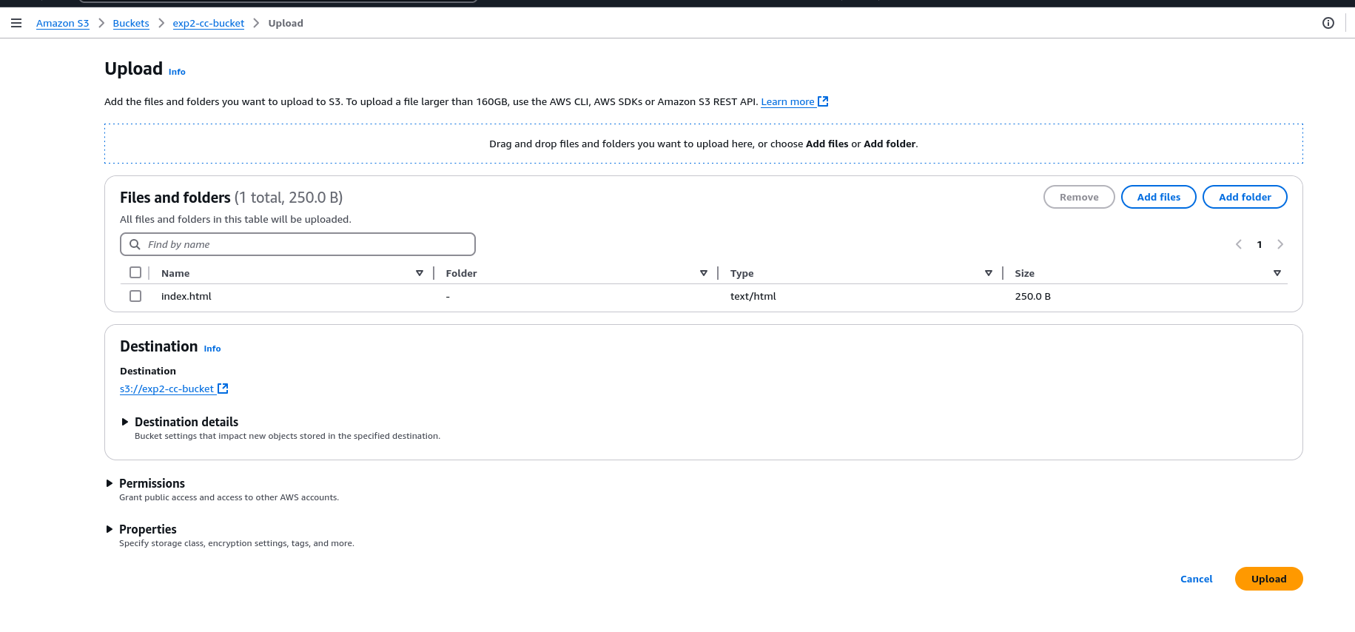

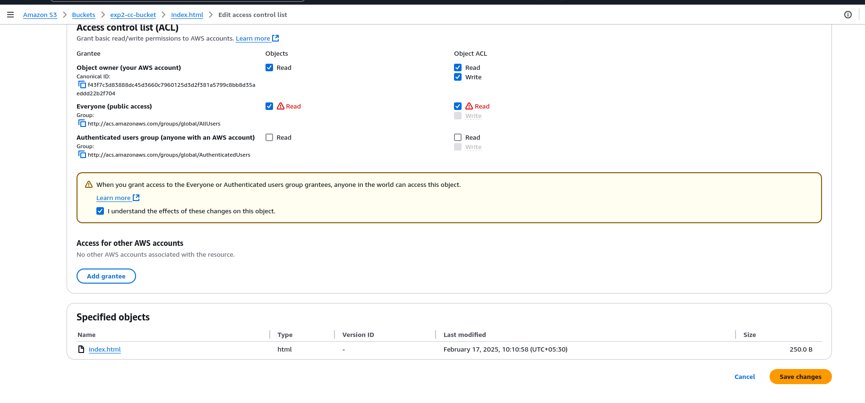Set proper permissions to manage access

HTML File Output:- <https://exp2-cc-bucket.s3.us-east-1.amazonaws.com/index.html>

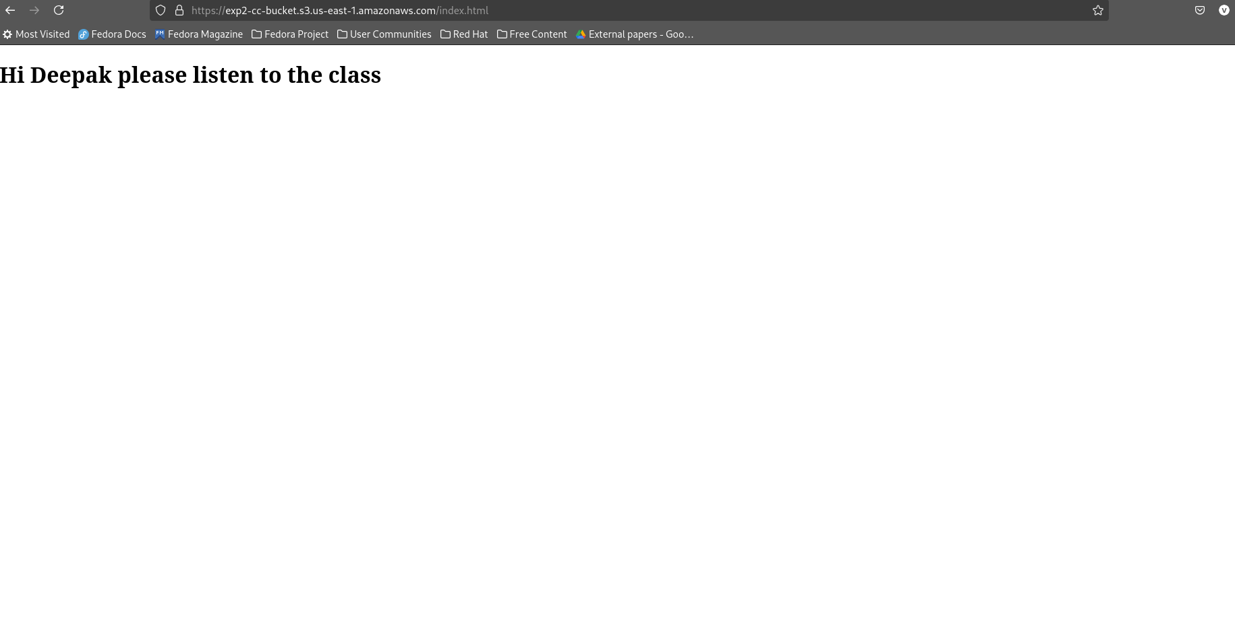

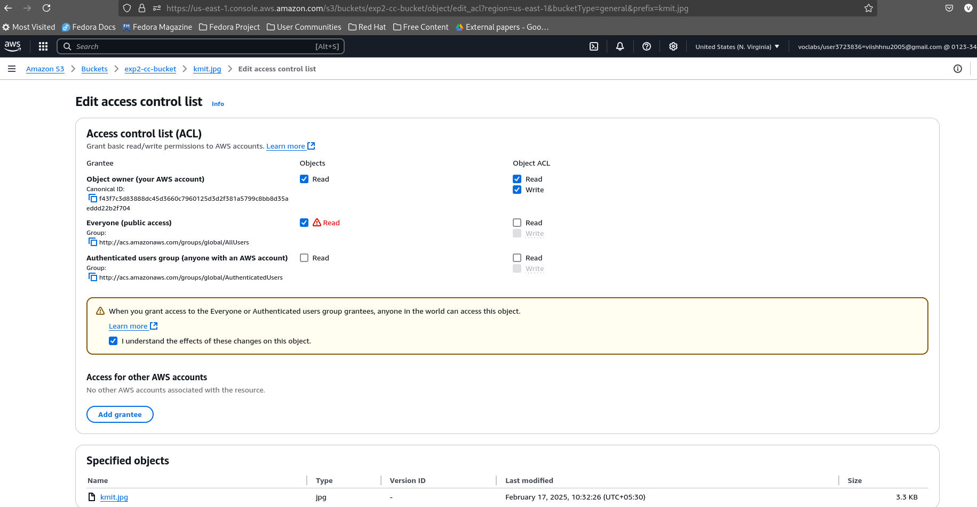

Image:- https://exp2-cc-bucket.s3.us-east-1.amazonaws.com/kmit.jpg

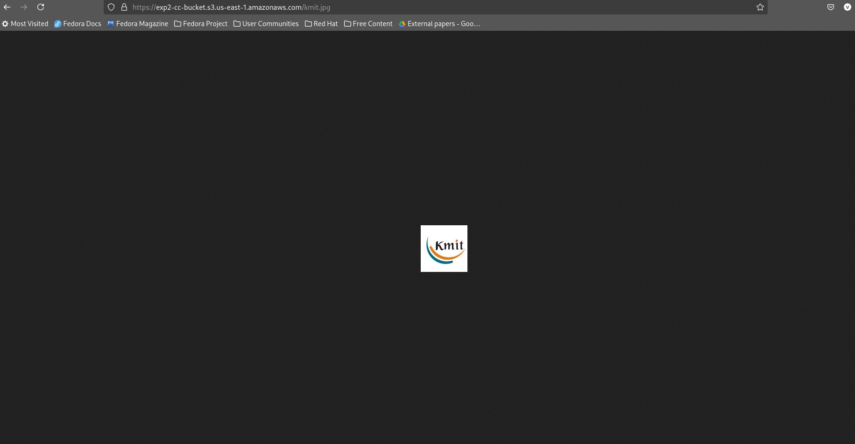

PDF [File:-](../../../../../-) https://exp2-cc-bucket.s3.us-east-1.amazonaws.com/3-2+syllabus.pdf

